roid

217, Sheikh Rashid Building

P.O Box 56272, Dubai

United Arab Emirates

Tel: +971 4 2973236 / 04 2974007

Email: uae@verbat.com

PROJECT   
PROPOSAL

**Mobile Valet Parking System**

|  |  |
| --- | --- |
| **Prepared for:** | **Submission Date:**  23 Nov 2017  **Proposal ID:** AD/BP/23112017/1343/1 |

___________________________________________________________________________________________________________________________________________  
Conﬁdentiality Notice: This Proposal is conﬁdential and contains proprietary information and intellectual property of Verbanet Technologies LLC. Neither this proposal nor any of the information contained herein may be reproduced or disclosed under any circumstances without the express written permission of Verbanet.

© 2017 by Verbanet Technologies LLC. All rights reserved. Confidential.

___________________________________________________________________________________________________________________________________________

Project Contacts

|  |  |
| --- | --- |
| Client Information | |
| Project Name | Mobile Parking Services application |
| Client Name | Oscar Valet |
| Client Address |  |
| Contact Person |  |
| Contact Person Email |  |
| Contact Person Phone Number |  |
| Verbat Information | |
| Contact Person | Joyce Daniel |
| Contact Person Phone Number | +971 42973236 |
| Contact Person E-Mail | [joyce.daniel@verbat.com](mailto:joyce.daniel@verbat.com) |
| Address | PO Box 56272, Dubai, United Arab Emirates |
| Physical Address | 217, Sheikh Rasheed Building, Hor Al Anz East |
| Project Information | |
| Proposed Technology/Methodology | Xcode, Java, Android Studio, Swift |
| Anticipate Start Date | NA |
| Proposal Valid For | 30 Calendar days from the submission of the proposal |

**Table of Content**

1 Company Background 6

2 Scope of Work 6

2.1 Key Platform Stakeholders / “Actors” 6

2.2 Stand-Alone Fixed Bid 7

2.3 Solution Objective 8

2.4 Advantages of Proposed Solution 9

2.5 Why Verbat 9

2.6 Key Differentiators 10

2.7 Technology & Services 11

3 Functional Specification 12

3.1 System Architecture 13

3.2 Application workflow 14

3.2.1 Workflow for Guests 14

3.2.2 Workflow for CVA 14

3.2.3 Alternate Workflow for guest’s without mobile devices 15

3.2.4 Workflow for Restaurants 15

3.3 Application Screens 16

3.3.1 Guest 16

3.3.2 Valet (CVA) 23

3.3.3 Restaurants & Malls 27

4 Nonfunctional Requirement (Others) 28

5 Assumptions 28

6 Out of Scope 30

7 Technology Solution 31

7.1 Proposed System Environment 31

7.2 Technical Configurations 32

7.2.1 Development Tools 32

7.2.2 Browser Compatibility 32

7.2.3 Hardware Interface 32

8 Commercials 32

8.1 Web Application 32

8.2 Payment Terms 33

8.3 Mode of Payment 33

9 Delivery Management 33

9.1 Project Management 33

9.2 Roles and Responsibilities 33

9.3 Delivery Activity Summary 35

9.4 Project Implementation Plan 35

9.5 Deliverables 35

9.6 Estimated Delivery Time 36

9.7 Deliverables 36

9.8 Release Planning 36

9.9 Risk and Contingency Planning 36

10 Change Management 37

11 Miscellaneous 39

11.1 Acceptance Criteria 39

11.2 General Terms and Conditions 39

11.3 Assumptions and Dependencies 40

11.4 Source Code & Intellectual Property Rights 40

11.5 Maintenance & Support 41

11.6 Service Level Agreement 42

12 Our Clients 43

# Company Background

Oscar Valet Services works to provide businesses, from large multinational corporations to small business organizations, with the latest valet solutions in the world. The company offers a wide variety of valet related services such as

* Valet Parking Services.
* Car Parking Rental and Management Services.
* Event Management Services.

# Scope of Work

The Oscar Mobile Application is used by three types of users i.e.

* Guests
* Valet’s (CVA)
* Restaurants / Malls

Each user has access to different aspects of the application. For example guests can use the application to register their vehicles and generate QR codes for parking. The Valet application can scan QR codes and track the parking spots of the cars that they park. The restaurants can validate the customer and their car. Restaurants can also notify the valet’s when it is time to retrieve the cars for the guest so that they can take procession of it.

The scope of the application is to develop the modules required for each set of users. At a high level three separate mobile applications will be developed for each set of users. These applications work together in concert to facilitate the valet parking service.

## Key Platform Stakeholders / “Actors”

The application is divided into different modules and each module can be assigned access to different users / actors or to different roles defined in the application. Roles typically represent the key stakeholders of the system.

**Guests:** Guests can download the application and do the following

* Register and manage their vehicles
* Select the vehicle and generate a QR code at the valet service
* Use the QR code to check into a restaurant and avoid parking fees
* Use the App to retrieve their car from the Valet service
* Valet is notified of service fee waiver and request to retrieve car for guest

**Valet Service:** The valet service app has the following features

* Scan QR code to check in a car
* Receive notification when a guest has used a restaurant within the facility
* Receive guidance for available parking spots to park the car
* Record the location of the car (Using QR code or manually)
* Record damages on the car by capturing images using the phone camera
* Receive notification to retrieve a car
* Receive notification to collect fees from guest ( by scanning QR code from restaurant)
* Receive payment
* Checkout the car for the guest

**Restaurants & Malls:** Restaurants and Malls validate the QR code generated at the valet stations. By validating the QR codes, the restaurant and malls waive the parking fees from the guest during check out

## Stand-Alone Fixed Bid

Verbat will be following a stand–alone fixed bid solution delivery model wherein the required solution would be devised and a suitable pricing would be offered.

## Solution Objective

The primary purpose of the application is to improve parking lot management. A three pronged approach is taken to provide a unique solution in the management of parking lots for malls and restaurants.

The unique value proposition that this solution brings are

**Logistics**

* Easily identify free parking spaces in the parking lot
* Easily identify where a vehicle has been parked

**Valet Service**

* Easily manage risks by recording any damages on the vehicle
* Automate parking management by tracking vehicle details such as check in, check out, fee waivers etc.
* Enhanced user experience while utilizing fewer resources
* Better time management

Verbat shall develop three different Apps focused on the Valet service, guests and restaurants or malls

Verbat’s Solution architects have conducted a thorough research on the requirements and have come to the conclusion that our proposed solution, which is detailed further in this document, will meet the requirements put forth by the client. And the proposed solution will be delivered in a phased approach as per Verbat’s stand-alone fixed bid solution model.

**Strong and Scalable platform:** The platform proposed will be strong and scalable enough to accommodate future enhancements.

**Accelerated solution:** The framework would act as a solution accelerator. It would provide the basic building blocks which could be reused in future for building new components and features.

**High performance:** The light weight framework used consumes fewer system resources thereby making the application perform faster.

**Security:** The application will be developed considering various aspects of security.

## Advantages of Proposed Solution

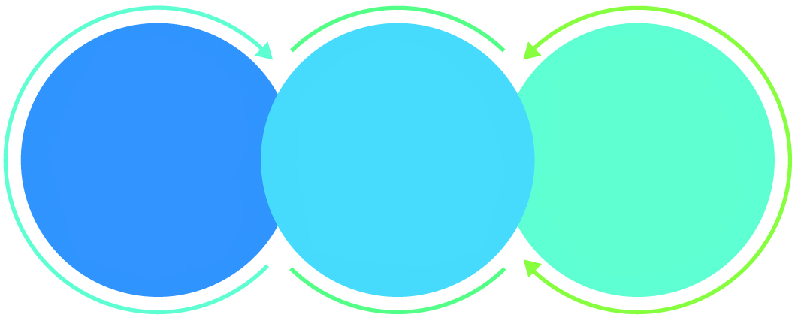

01

Agile development offering reliable, secure solution

02

Smooth transition and quicker completion of processes

03

User friendly interfaces enabling easy navigation between screens

## Why Verbat

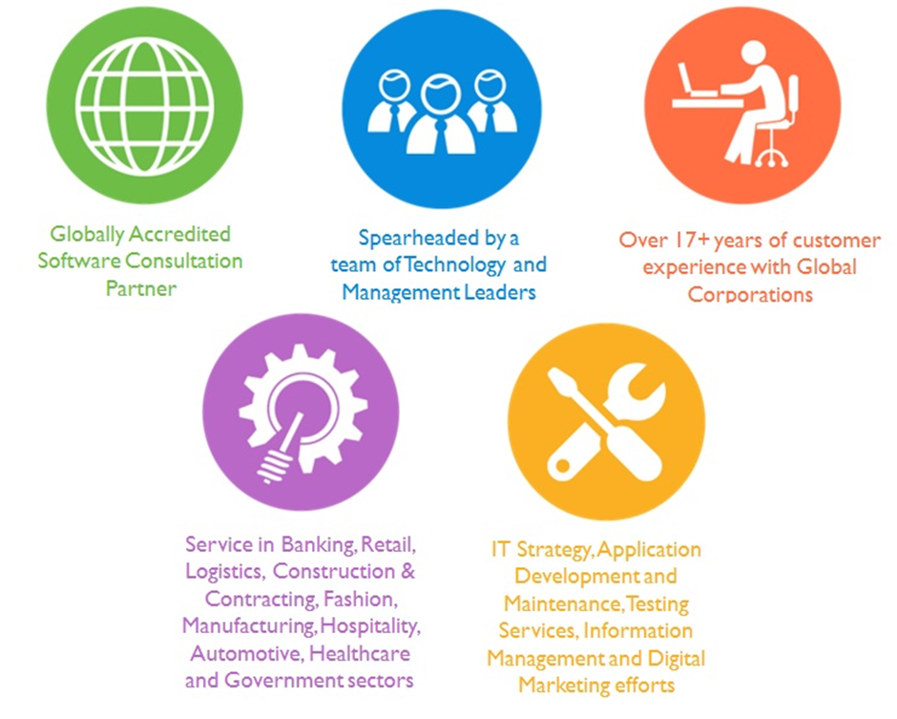

## Key Differentiators

Delivered digital transformation expertise to global customers for over a decade by following industry best practices to maximize ROI for client

Keen technology intelligence combined with aggressive market research to deliver solutions that achieve results with measurable value

Enable access to global consulting expertise with strong local market and business knowledge

Commercial Model that is customizable for your business needs

Services that are designed to optimize applications for improved performance and overall efficiency

1,000,000 plus man-hours of expertise in technology frameworks spanning Microsoft, Open Source, mobility platforms and other proprietary IT technology

Partners top technology vendors to bring in the latest and best services in integration, collaboration, and development

Commercial Model that is customizable for your business needs

Proven Methodologies & Processes

Investment in R & D

Strong Local Presence

Flexible commercial Models

Technology Associations

Software Development Experience

Offshore Development Centre

Quality Assurance & Testing

## Technology & Services



Technology  
&  
Services

Cloud/Traditional Hosting

User Interface & Design

Digital Marketing

Mobility Solutions

Testing Services

Application  
Development

# Functional Specification

|  |
| --- |
| **Mobile Design and Development** |
| Basic Setup |
| Splash Screen |
| Registration page |
| Login Page (Guest, CVA, Restaurants and Malls ) |
| Guest Dashboard |
| Guest Info Screen |
| Guest Car list page |
| Guest add new car |
| Guest car edit and delete |
| Guest Quick request |
| Generate Barcode (QR code integration) |
| Car Selection |
| Push notification |
| QR code page |
| Retrieve car |
| Rate us |
| Feedback |
| Contact us |
| Logout |
| CVA Dashboard |
| CVA Check-in |
| Barcode Reader page |
| API integration and QR code reader integration |
| Vehicle detail page |
| Parking detail page |
| Take image option |
| Photo gallery |
| Scan Parking QR Code page |
| CVA check-out(Show car detail and validation) |
| Fees Detail enter page |
| CVA logout |
| Restaurant Dashboard |
| Validation |

Figure Overall Workflow

## System Architecture

The mobile applications will be developed on an existing framework. The client has a web application framework that manages the whole process. The mobile applications being developed shall communicate with the existing framework using API calls.

## Application workflow

### Workflow for Guests

### Workflow for CVA

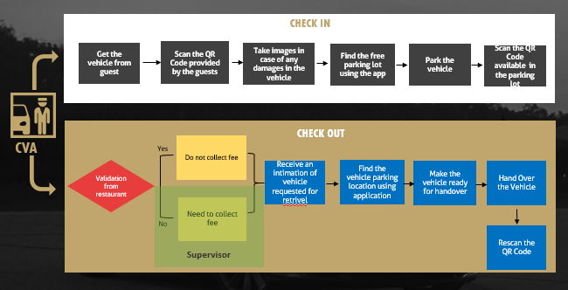

### Alternate Workflow for guest’s without mobile devices

1. Oscar services (CVA user) enter car details of the customer in their mobile device during check-in
2. Oscar services (CVA user) provide plastic cards with QR code to customer and retain one card with Oscar services
3. Oscar services (CVA user) park the car in the parking location and enter parking lot number
4. Restaurants can use validator to validate the card with  the customer
5. Existing web application will get a notification/message of validation from the restaurant
6. Oscar services (CVA user) shall then retrieve the car and handover to customer if the card is validated by the restaurant.
7. If the card is not validated by the restaurant, they have to pay fee as defined in the PPT

### Workflow for Restaurants

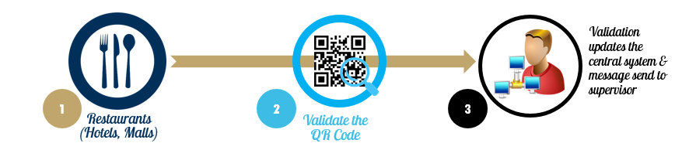

## Application Screens

### Guest

#### Initial Screen

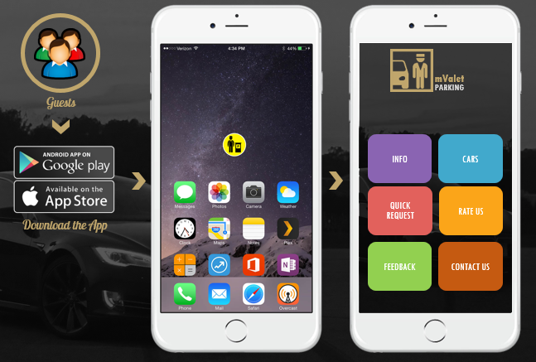

#### Info Screen

#### Add New Car

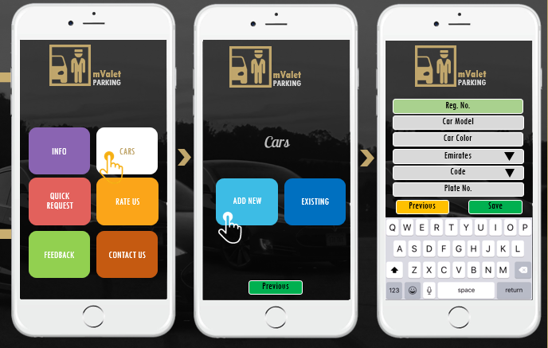

#### Edit Existing Cars

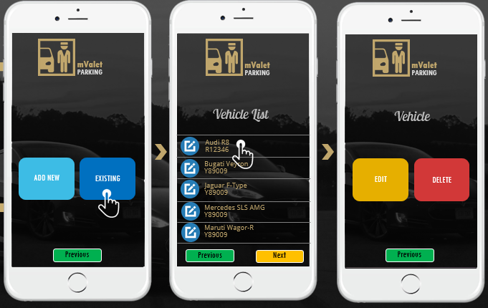

#### Edit Car Details

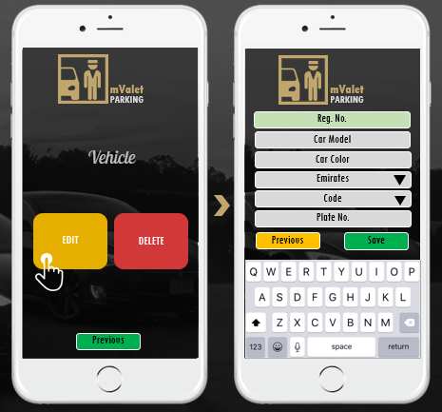

#### Quick Request

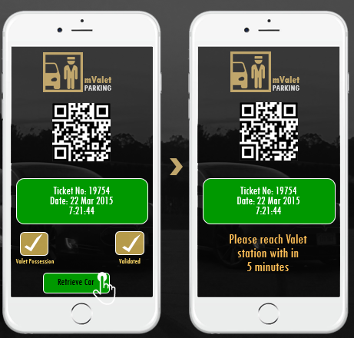

#### Rate Us

#### Feedback

#### Contact Us

### Valet (CVA)

#### Login

#### Check In

#### 

#### Damage Control

#### Parking Lot QRCode Scan

#### 

#### Check Out

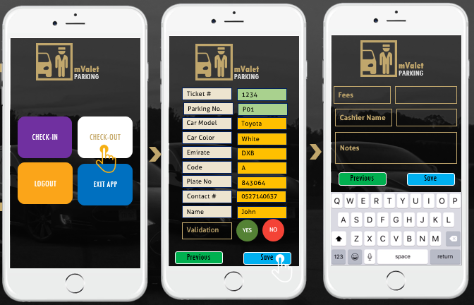

### Restaurants & Malls

#### Login / Validation / Logout

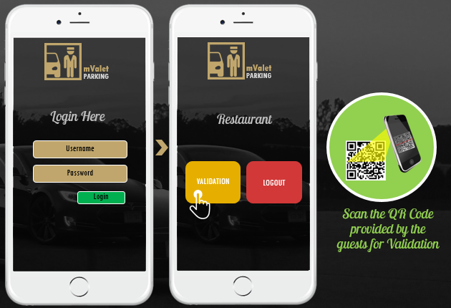

# Nonfunctional Requirement (Others)

|  |  |
| --- | --- |
| **Requirement** | **Details** |
| User Experience and  UI Design | * The application will be developed only in English and Arabic * The layout and graphical components will be created considering the usability factors |
| Performance | * Application will allow users to have smooth and quick access to the information or services they require. |
| Security | * The system will be protected against attempts of security breaching that may arise. * Web security standards will be followed. |

# Assumptions

The project solution and technology is created from the initial understanding of the requirement shared with Verbat through mails and meetings. The proposed solution is based on the following assumptions:

* Client to provide Verbat with the branding guidelines.
* The proposed application will be bilingual (English & Arabic)
* Client will purchase the necessary templates needed for development
* Client shall provide licensed images and logos in specified size & format
* Requirements should be well defined, agreed and signed-off by the client
* Internet connectivity is required for the functioning of the web application.
* Development Contingent upon timely feedback from client
* Client will provide access to Android and Apple Store to deploy the application
* Application will be developed for portrait mode only
* Application will be developed for Mobile devices only
* IOS 6+ and android marshmellow

# Out of Scope

Following are considered to be out of scope while creating this proposal.

* Purchase of images, fonts
* Adding new features to the application other than mentioned in the functional specification.
* Any language other than English & Arabic
* Manual data entry
* Hardware Integrations / procurement and purchase
* Database migration
* Content writing
* Content or image procurement or uploading or editing.
* Annual Maintenance of the application (Bug fixing, debugging) - For AMC details, please refer section titled “Maintenance and Support”
* Physical deployment at client’s site
* Backup solution and Disaster recovery
* Application will not be developed for tablet devices

# Technology Solution

## Proposed System Environment



IOS / Android SDK

Android Studio

XCODE

SWIFT / Java

HTML / CSS3/ Jquery

**MS SQL2012  
Windows 8/10  
Web Services**

## Technical Configurations

### Development Tools

* Xcode / Java / Android studio, Swift
* Android / IOS
* HTML / CSS3
* Ajax, JavaScript, JQuery

### Browser Compatibility

* Chrome version: 56
* Firefox version: 51
* Edge version: 39
* Safari version 10.1

### Hardware Interface

* Apple 5s and above
* Google Pixel, MotoG 3 turbo

# Commercials

## Web Application

|  |  |  |
| --- | --- | --- |
| **No** | **Description** | **Amount (USD)** |
| 01. |  | 00,000.00 |
| 02. |  | 00,000.00 |
|  |  |  |

*Note:*

* *The above cost does not include Application hosting, integration, Project Management or deployment*
* *For change management cost, please refer to section 10 titled Change Management*

## Payment Terms

*Note: Payment should be made within 7 days from the date of the invoice*

## Mode of Payment

By Cheque / DD to Verbanet Technologies LLC

OR

Wire transfer to our bank account

Bank Name : Emirates NBD

Account Name : Verbanet Technologies LLC

Account Number : 1011492858201

IBAN Number : AE61 0260 0010 1149 2858 201

Swift Code : EBILAEAD

Bank Address : Mamzar Branch, Dubai

*Note: Bank charges incurred during wire transfer to be borne by the client. Any local taxes applicable to be borne by the client*

# Delivery Management

## Project Management

The Verbat development center strictly follows industry standards on quality. The project management is process governed by the Verbat Quality Management system and is put to verification through internal audit programs that happen from time to time.

Verbat will dedicate a project manager for the proposed implementation. Verbat proposes Client to identify one project manager who will be driving activities to be undertaken by Client to be the single point of contact for Verbat.

## Roles and Responsibilities

Verbat will assign a dedicated Project Manager/Project Lead to lead the project, who will be the first point contact for Client. He/she will be responsible for planning and managing the various activities within the project. He/she will work closely with Client Project Manager, to give periodic status updates and ensure high level of visibility and comfort on the progress of the project.

The Project Manager/Project Lead will lead the co-ordination between Verbat and Client, thus enabling smooth transitioning of Client requirements to the Verbat’s offshore delivery team, and provide visibility as well as comfort on the progress of the services to Client.

He/she will have periodic meetings with Verbat’s Senior Management, thus ensuring Verbat’s Management commitment and focus on Client initiatives.

## Delivery Activity Summary

|  |  |
| --- | --- |
| Activities | Description |
| Detailed requirement Analysis | Verbat team to conduct detailed study of requirement for the phase. If clarification is required, team will reach out to Client for more information and/or time for discussions. |
| DB Design | DB design for central and test DB. |
| Software Requirement Specification document (SRS) | Once the requirement analysis is completed, Verbat team will submit the SRS document for approval |
| UI/UX Design, Prototyping | Based on the SRS, Verbat UX/UI team will work on the UI/UX of the screens and submit a prototype for approval |
| Functional Specification Document (FS) | Once the Prototype. UI/UX is approved, Verbat shall submit an FS document for approval. |
| Development | Actual system development starts based on the FS. This involves detailed design and software development of Web Application. |
| Testing | Test Planning, test plan creations, internal, integration testing and user acceptance testing. |
| Deployment | Deploying the latest built in the Verbat Test Server. |

## Project Implementation Plan

Verbat will be providing the solution in a stand-alone fixed bid approach which ensures minimum viable solution for quick wins with core focus on the long-term business objective and outcome. Once the implementation is over, Verbat will initiate the application maintenance process (once the maintenance contract is signed) which continues to extend after the implementation.

## Deliverables

* Project Plan
* Design templates
* Functional Specification Document
* Prototype of the application
* Test Plan Document
* User Manual
* Source Code
* Fully Developed & Tested Application (IOS and Android Mobile App)

## Estimated Delivery Time

The effort estimated for delivering the application is as follows;

* Delivery of Prototype: 5 Working Man Days
* Days for the development of the application from the Date of Approval of the Prototype: 45 working man days

## Deliverables

IOS and Android Mobile Application for

1. App for guests
2. App for CVA’s (Car Valet Assistants)
3. Restaurants & Mall App

## Release Planning

* Client will be informed about the release date and time through email.
* Client performs the UAT

## Risk and Contingency Planning

Verbat has identified various risk factors associated with this assignment and understands the impact of these risk factors on the project schedules. The objective of this section is to highlight for both Verbat and client, the risk factors, to analyze the impact of the risks on project execution, and to propose strategies to control and reduce the impact of the risk factor.

These various risks, which could arise during the project, are tabulated below along with mitigation implementation.

| Type of risk | Impact | Risk Mitigation | Risk Handling |
| --- | --- | --- | --- |
| Scope Creep | H | Functions and features will be detailed in system requirement documents and will go through client approval. Once this document is approved, any change to requirement will go through change management review for possible impact assessment. | Proper change management procedure will be implemented. |
| Delay in customer feedback | H | The plan is prepared with enough lead-time for customer reviews and approvals.  The customer is indicated with the dates when the document is expected after review and approval. | The request for feedback will be escalated if not attended at the right time so that the schedules are not affected. Deemed acceptance criterion is set up front and will be followed. |
| Non-availability of necessary software’s, frameworks, database instances and infrastructure at client’s hosting environment(If hosting support is provided by Verbat) | M | Client will be informed in advance on these requirements. | Possible impact to schedule. |
| Manpower attrition | L | All efforts would be made to ensure process dependence rather than being person dependent. As a risk mitigation plan Verbat will train backups. | A new person will be identified as early as possible, provided the required project-specific training and mentored by the senior members of the team to minimise impact of attrition on the project. |

*H-High, M-Medium, L-Low, NA-Not Applicable*

# Change Management

Any addition which comes out of the project scope, upon and after the launch of the tool will be considered as change management. Verbat recommends the following change management procedure for the same.

* Any change which comes out of the project scope, which was discussed, documented, and mutually approved by both the parties in the requirement stage, will be carried out only through raising a change request.
* Change request will be studied and an impact analysis on the existing work flow will be performed.
* On finalizing the impact, effort estimation for the change will be calculated and raised as additional requirement.
* Verbat will initiate the change request only after getting a formal approval from the client for the additional changes raised.
* Any change from the scope will be charged at **USD ----- per man day effort** and approval from the clients will be availed before commencing on any change management.

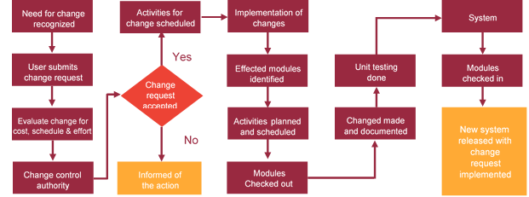

# Miscellaneous

## Acceptance Criteria

* UAT sign off should happen within 14 Days from the release of the application/ Phase and the acceptance confirmation needs to be mailed to Verbat failing which Verbat will consider the project as approved by the client.
* Any comments or reason for rejection need to be documented and the same needs to be sent as an email from the official mail id of client to Verbat.

## General Terms and Conditions

* All the projects activities will be carried out from our off-shore development center in India
* The scope of the project is to develop the Application as detailed in the scope of the project and mentioned in this proposal. Any changes or additions will have to go through change management.
* This proposal and all technical/ functional specifications have been derived or concluded from the data shared via email / information's transferred during the initial requirement analysis meetings and conversations. Verbat reserves the right to amend the terms of this proposal, should the SOW terms, functional features and functionalities change during the course of the project
* Application will be best viewed only in the environment mentioned in this document
* All the documentation will be provided in English.
* Third party components may be used to develop this application.
* All Source Code and other project artefacts would adhere to the Verbat document templates and internal coding standards
* Client shall provide the respective enterprise apple store and Google play store accounts for development and production
* Acceptance criteria shall be based on the clauses which were mutually discussed between Verbat and client at the Requirement Analysis phase and the same will be documented and approved by both parties through official emails
* In case Client requires any extension of the proposed acceptance schedule, the associated effort and cost of such extension can be mutually reviewed.
* For any circumstances if project needs to be put on Hold / Stop it requires minimum request notice period of 2 weeks along with duration for which request will be addressed by management and final decision on the request will be based on that
* If deployment is done in client’s server, Verbat cannot be held responsible for any performance issues arising due to hardware malfunctions.
* Source code will only be delivered or uploaded on the Production Server once the due payments are made.

## Assumptions and Dependencies

* Detailed system study is required before the start of the project.
* During the requirement gathering phase, authorized personnel from the Client’s side is expected to be available for discussion and finalizing the HLD (High Level Design), before development commences.
* Type of reports and formats, if under the scope of the project, needs to be specified by Client before project sign off.
* Workflows if under the scope of the project, need to be specified/ confirmed by client before project signoff.
* All queries regarding the client requirement and any queries which may hinder the project advancement at any stage should be answered by the client within 24 hours from the time of initiation, failing which the time delay will get added to the actual effort which was estimated.
* Verbat assumes that all sign-offs from Client will be provided within agreed and specified timeframe.
* Client will provide all the necessary contents, both text and image, before starting the project in the format suggested by Verbat (if any).
* The client should provide the relevant information and data well in time for the execution of a related activity. Non- availability of this information or data may lead to an interruption of work which may result in a delay in delivery as well as additional costs to the client.

## Source Code & Intellectual Property Rights

* Upon completion of the Project and 100% completion of the payment, client will have access to the source code except for propriety codes, developer tools and third party application etc.
* The solution offered will be the intellectual property of the client and will be made available to the client on an “unlimited license” basis.
* Modifications by third party/person: No person or organization, other than Verbat or any person authorized by Verbat in writing, has any permission to modify/change the software Solution to be eligible to get continued support from Verbat as per the support terms defined under this document.
* Liabilities/Damages: Verbat accepts no liability or damages of any kind arising out of use or non-use of the software delivered. The responsibility of testing of software lies with Client.

## Maintenance & Support

* Maintenance contracts by default are supported as per the basic SLA terms.
* **AMC with Basic SLA is charged at 20 % of the total project value**. Additional Effort/change management request will be added towards Total Value of the Project to determine the AMC value.
* Maintenance support is limited to providing application support for ensuring the consistency of the look-and-feel, bug fixes and user issues i.e. maintenance and support of the existing features of the application.
* Support does not in any way cover providing technical or other support to the end users. The maintenance agreement does not include functionality changes or feature additions which are handled as change requests which will be charged AED 1200 per man day. AMC does not include server support, maintenance and application deployment.
* AMC charges will cover Off-Site Support and Debugging. Support includes E-mail, Telephone and Chat unless explicitly specified. In the event, the application is hosted with the client; necessary remote desktop connectivity should be provided for carrying out maintenance activity.
* Gap in AMC - In case if the client does not opt an AMC for a year and want to renew it after that period, 50% of the AMC amount for the year for which AMC is not taken will also be payable if the client wishes to renew the AMC contract.
* Note:
  + Please note that the AMC support shall start only after all the necessary sign-offs (AMC Document) to this effect have been given.
  + It is not mandatory that the client should opt for an AMC. The client will still be supported on an ad-hoc basis on an agreed man-day rate.
  + AMC Payment Terms: 100% to be paid as advance.

## Service Level Agreement

|  |  |  |  |  |
| --- | --- | --- | --- | --- |
| **Key** | **Max Response Time** | | **Max Resolution Time** | **Target** |
| Basic | 1  working day | 3 working days | | Request / incident / problem tickets |
| Advanced | 5 Business Hours | 12 Business Hours | | Request / incident / problem tickets |
| Priority | 3 Business Hours | 5 Business Hours | | Request / incident / problem tickets |

Note:-

* We provide Basic SLA as standard with AMC while Advanced and Priority SLAs attract additional charges.
* Time zone applicable as per India time zones (3:30 AM GMT to 12:30 PM GMT- Monday to Friday).

# Our Clients

**UAE University**

Education

Transportation

**Canada Cartage**

Construction

Services

Finance

We look forward to hearing from you soon and hope that you will give us the privilege to work with you in meeting your business goals. Thank you.

Thank You



©   
1999 - 2017. All Rights Reserved   
Verbanet Technologies LLC  
www.verbat.com